Name: __________________________________________________ Date: ______________

Lab #___- H-R Diagram # of minutes = _____ Score = _____/25 = _______%

Introduction
The Hertzsprung-Russell Diagram, or H-R Diagram, is a graph that represents a star's temperature plotted against its absolute magnitude. This diagram can be used to determine the stage of a star in its life cycle.

Directions
1) Plot the following data on the attached graph. Use the data from the chart for The 20 Nearest Stars to Earth and The 20 Brightest Stars Seen from Earth.
2) Plot temperature on the x-axis (dependant) and magnitude on the y-axis (independent)
3) Use a "+" sign for all stars nearest to earth. DO NOT CONNECT THE POINTS.
4) Use a "O" sign for all the brightest stars seen from earth. DO NOT CONNECT THE POINTS.
5) Answer the conclusion questions.

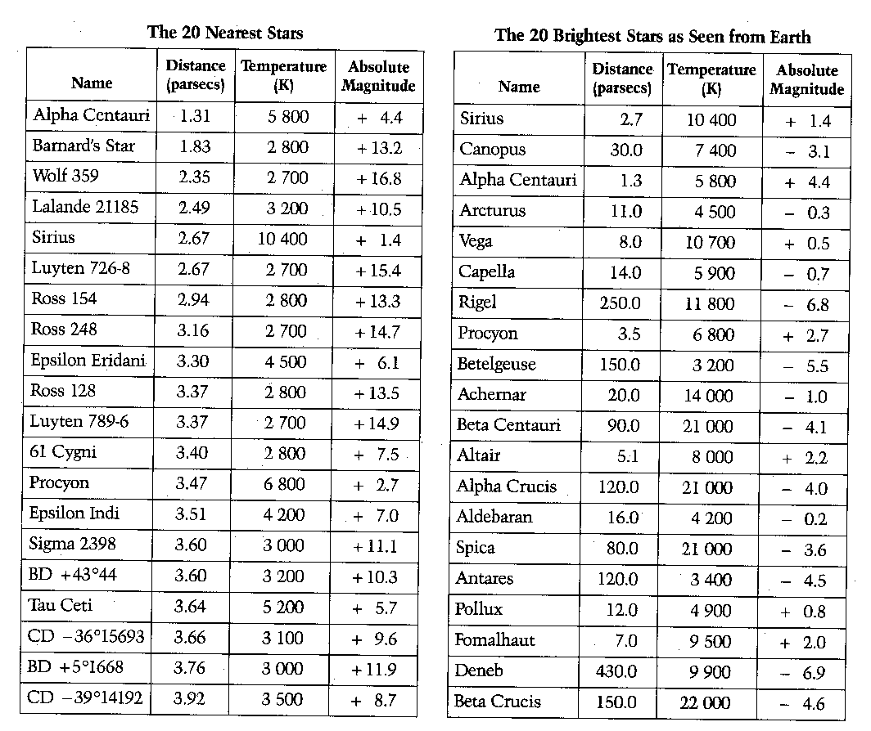
GRAPH = 10 POINTS [THERE ARE 40 STARS TO PLOT]
Directions: Use pg. 15 of the ESRT to fill in the characteristics of each star listed below.

Name of Star | Surface Temperature (K) | Color | Classification
Alpha Centauri

Barnard’s Star

Sirius

Procyon

Rigel

Betelgeuse

Aldebaran

Spica

Pollux

Deneb

Beta Crucis

Canopus

Sun

Conclusion Questions [15 pts]

1) Compare the two data tables, and note that some of the stars appear on both lists. List the stars that are found on both lists. [1]

2) Does this indicate a relationship between the two variables? If so, explain the relationship. [1]

3) Using the H-R diagram in your Earth Science Reference Tables, are any of the stars White Dwarfs? If so, list them. [1]

4) Our sun has a temperature of 6000 Kelvin and a magnitude of +4.7. Put a star on the chart to represent our sun. What category of star does our sun belong to (use your Earth Science Reference Tables). [2]

5) Betelgeuse is 150 parsecs away from the earth and only has a surface temperature of 3200 Kelvin, yet Betelgeuse is one of the brightest stars seen from Earth. What does this indicate about the size of the star? Explain your answer. [2]

6) How does the H-R diagram indicate age of stars? Explain your answer. In your answer, discuss the age of our sun in comparison with Betelgeuse. [2]

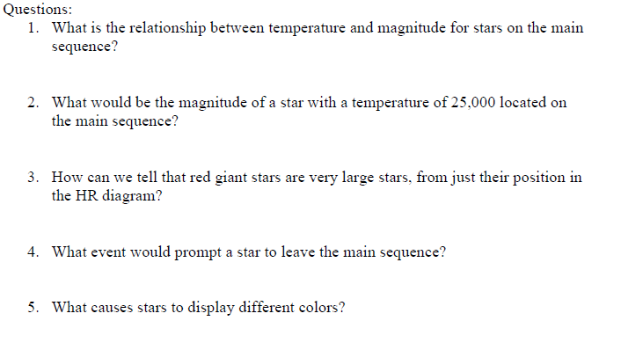
7)
8)
9)
10)
11)
[1]
[1]
[1]
[2]
[1]

Extra space to write your answers.

__________________________________________________________________________________________________________________________________________________________________________________________________________________________________________________________________________________________________________________________________________________________________________________________________________________________________________________________________________________________________________________________________________________________________________________________________________________________________________________________________________________________________________________________________________________________________________________________________________________________________________________________________________________________________________________________________________________________________________________________________________________________________________________________________________________________________________________________________________________________________________________________________________________

